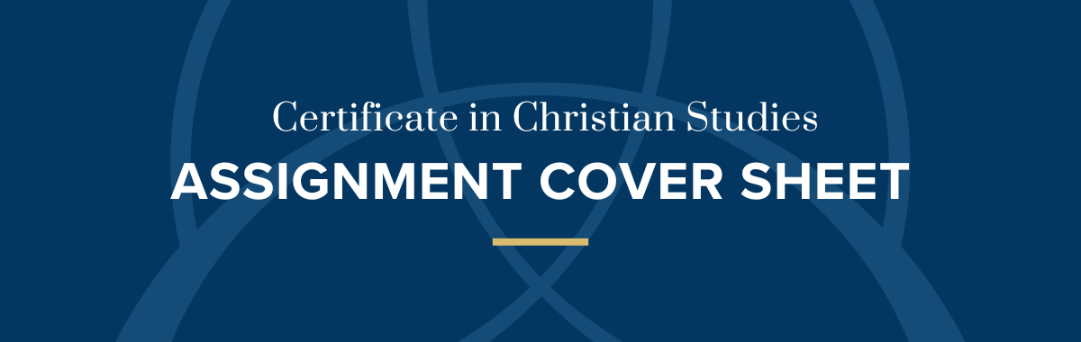
Student Name:
Unit:
Question:
Teacher:
Due Date: |  | Word Count:

Result Distinction Credit Pass+ Pass Revise
Comments:

Marker: Date:
Email is our preferred assignment submission method:
Email - CCS@ttc.wa.edu.au
For alternative submission methods please contact the CCS Coordinator

