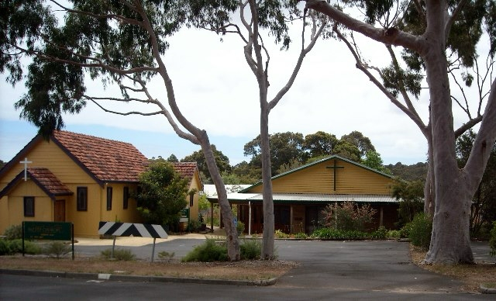

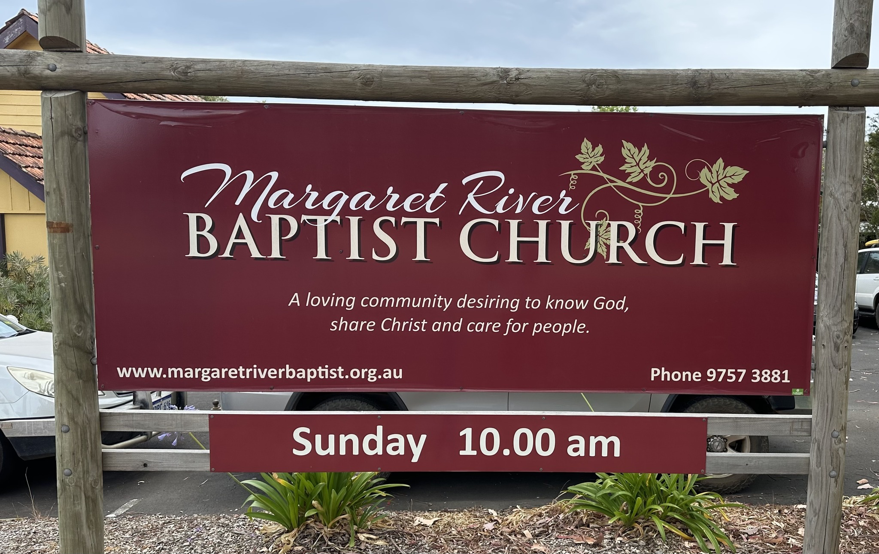

Welcome!

Thank you for expressing an interest in finding out more about the role of Part-Time Pastor at Margaret River Baptist Church Inc (MRBC).

This Information Pack provides an overview of MRBC, what happens in our church, along with the expectations of the role and the requirements for suitable candidate/s.

All formal applications for the part-time position will need firstly to go to the Church Secretary and then taken to the Church Board. Church members will then have the opportunity to be involved in the selection process.

After reading through this information pack and seeking God’s guidance and wise counsel from trusted and godly friends, family and mentors, if you choose to proceed with an application, please submit the following documents and email these to the Church Secretary.

Attention to: Pastoral Call
secretary@margaretriverbaptist.org.au

1. Cover Letter;
2. Application addressing the Selection Criteria (see below);
3. Curriculum Vitae;
4. Working With Children Check, National Police Clearance; and,
5. Three ministry references, including one from a current mentor or pastoral colleague.

SELECTION CRITERIA:

Please address each of these areas in your application:

- Share a brief overview of your faith journey, including your decision to follow Jesus, and His call into ministry.

- Outline three strengths you have and why you believe they could be a good fit for the role of part-time pastor at MRBC.

- Identify two areas in which you feel you may need additional support or development if you were elected to the role of part-time pastor at MRBC.

- Provide insight into your personal life purpose as a Christian and how this fits into God’s plan for your life.

- Share your doctrinal position and how this shapes your ministry and life.

Thank you for your prayerful consideration for this position.

Grace and Peace to you in the name of our Lord Jesus Christ.

Bruce Godden
Chair, MRBC Inc. Board.

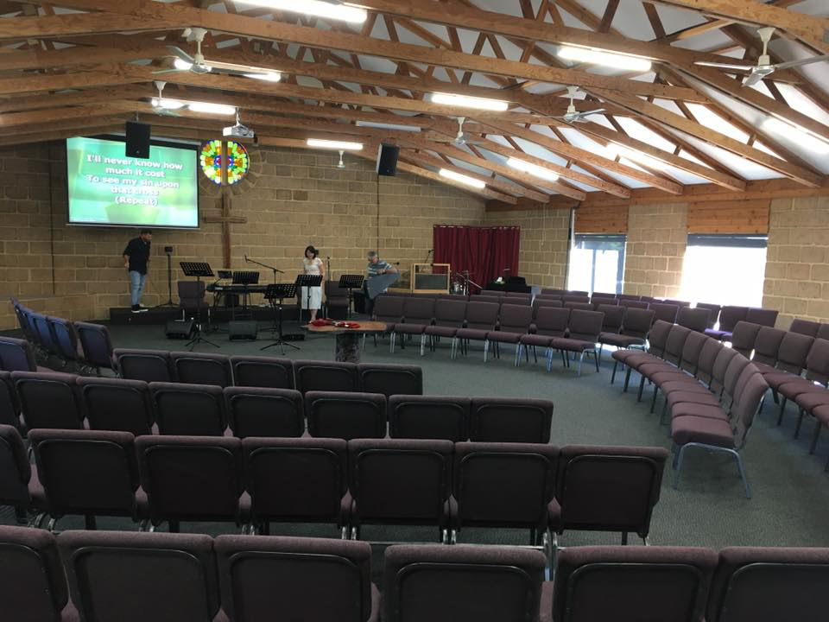

Margaret River Baptist Church:

Margaret River Baptist Church is a ‘smallish’ Baptist Church located in Margaret River Western Australia. The church was formed in 1986 and is an incorporated Baptist Church and a member of Baptist Churches of Western Australia (BCWA).

The Church has a membership of 21 adults, and a regular attendance of 20 - 40 people at our Sunday services. MRBC is a contemporary, family friendly church which is seeking to share the transforming love and gospel of Jesus with our community. The transient nature of the local community means that the congregation is dynamic, with new people always coming and loved people often leaving.

The church facilities include an auditorium which seats around 150 persons, an office,
infant room, kitchen, foyer, a separate small hall building, toilet block and playground.
A three-bedroom Manse on the church premises may also be available, if required.

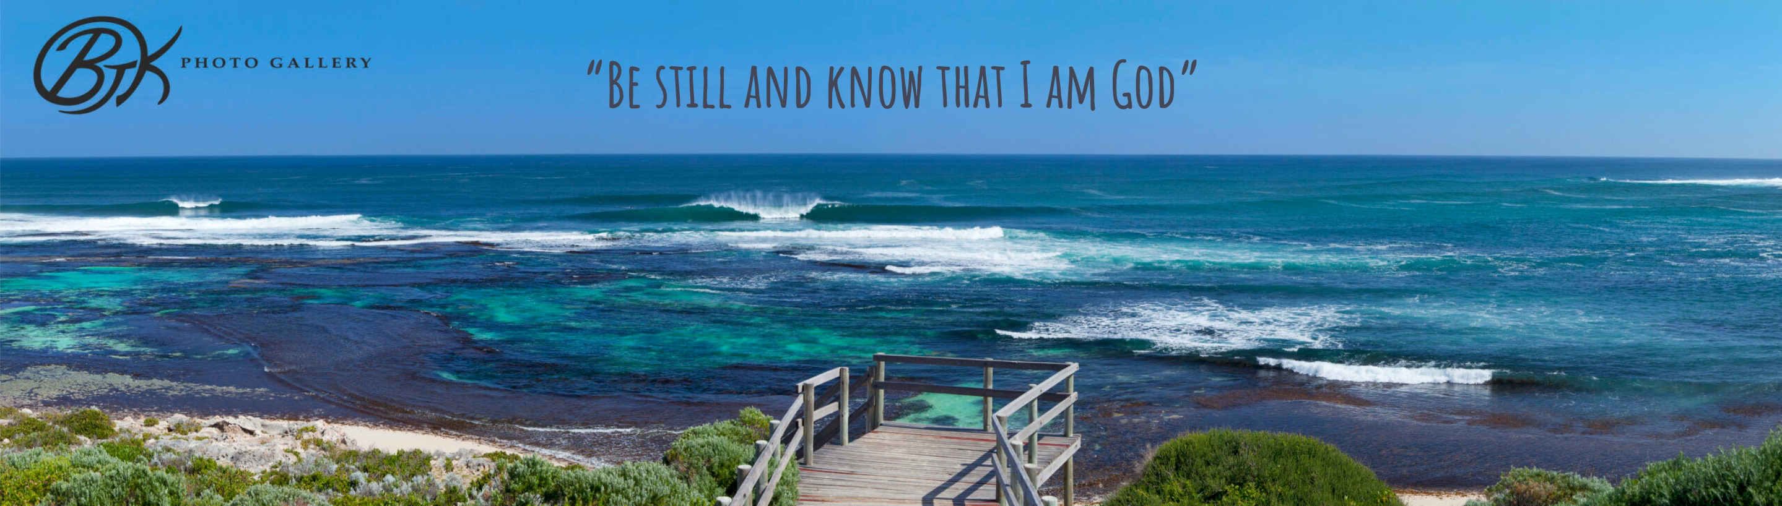

About Margaret River:

Margaret River is a regional town with a population of around 15,000 people. It is a historic town which was initially founded on both the dairy and timber industries. Tourism and viticulture have since become the dominant new industries. Margaret River is located 300 km south-west of Perth (WA’s capital city).

Margaret River is rich in cultural diversity, quality education (early childhood, primary, secondary, tertiary & TAFE), retail, hospitality and medical facilities. It has a great community atmosphere (with a wide range of sporting, arts and cultural groups) and opportunities for employment, entertainment and networking. It has modern amenities and is a family friendly town. It is a very popular tourist destination for those looking to discover the unique coastline (including world famous surfing locations), diverse flora and fauna, forests and caves.

The weather is warm / hot and dry in summer and cold and wet in winter, with perfect clear days in spring and autumn. Flights to nearby Busselton and well-used highways provide convenient access to other parts of the state and the nation.

Although there is a transient and tourist element of the population in Margert River there are also many who are ‘locals’; long term residents who are committed to calling the town area home, along with an increasing FIFO population who work elsewhere and fly home during weeks off. There is also a rich mix of cultural backgrounds, both from the local Indigenous First Nations people, to people from every corner of the globe. These factors bring a unique perspective to our community. Many people who move to Margaret River don’t have extended family here, so it’s a great opportunity for the church to become ‘family’ for many new residents.

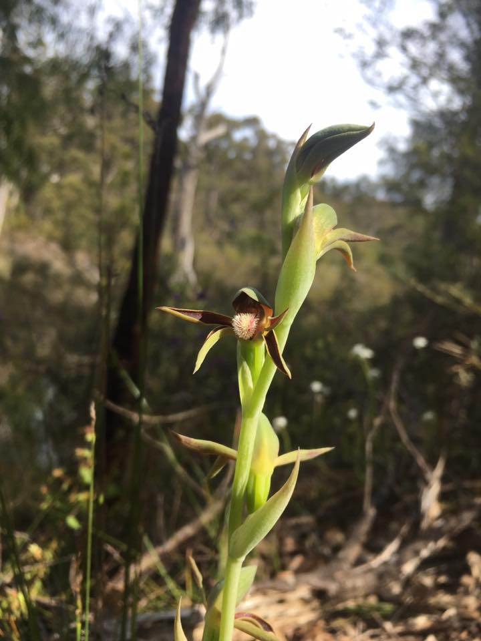

Our Vision:

SEEKING TO BE A LOVING COMMUNITY THAT :

FOLLOWS JESUS CHRIST
SHARES THE GOOD NEWS, and
CARES FOR GOD'S WORLD

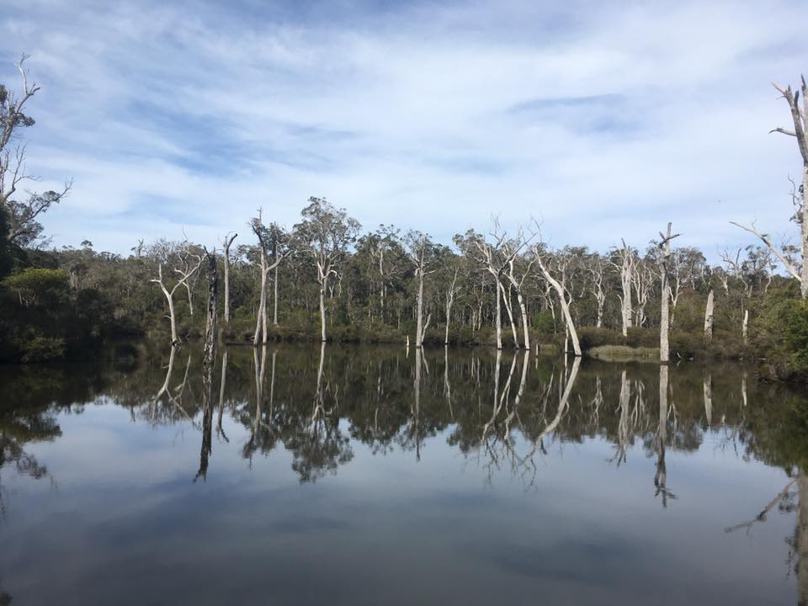

Church Statistics:

Weekly Attendances:
Sunday Services: 30 adults and children
Members: We currently have 21 members

Leadership:
Oversight Team Members: Three
General Board Members: Five

Current Paid Staff Positions:
Administrative Assistant: Part Time – 8 hours per week over two days

The Church Board including the Oversight Team and General Board Members, meets monthly to discuss and help decide on matters of spiritual and material importance, and governance within the Church. These meetings are opportunities to reflect, plan, and manage the ongoing stewardship of the church’s resources for the benefit of God’s Kingdom.

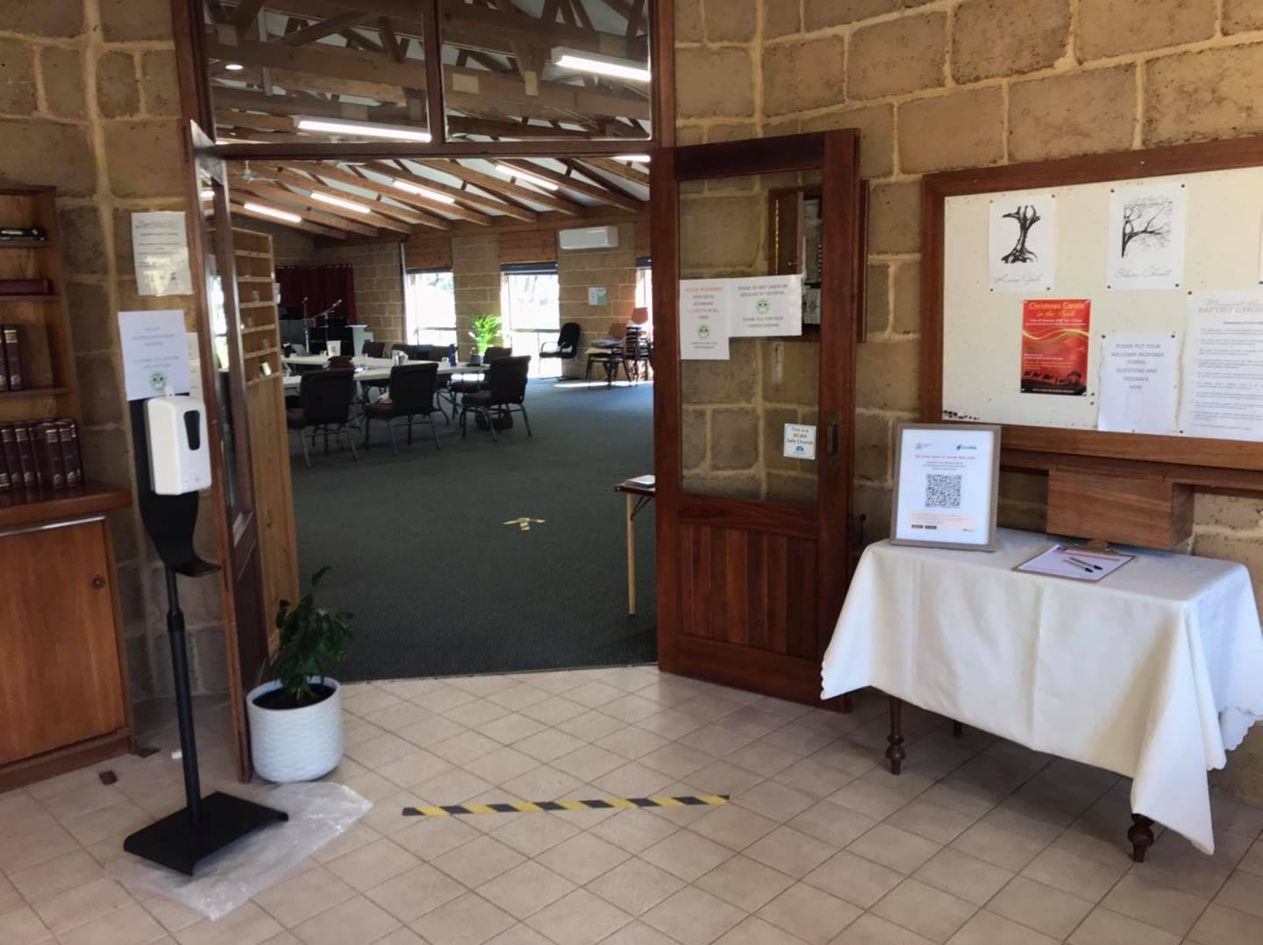

Sunday Morning:

Preparation for the 10.00am service sees the worship team arrive for rehearsal at 9.00am. We come together for prayer and practice, committing the morning to the Lord.

The welcome team arrives around 9.30am to set up the self-serve morning tea and prepare for greeting people as they arrive.

The service embraces a mix of contemporary praise and worship with a talented group of musicians, of which there are many. The service includes biblically based preaching, offering, prayer and bible reading. Currently children participate in the service. Were the number of children increase in population, there would be opportunities for structured activities created for them. Morning tea is available after the service where people are encouraged to mingle and chat with each other. Visitors are always warmly welcomed.

MINISTRIES:

Bible studies
Care Team
Craft Group
Missions
Kids ministries and youth group (currently on hold but possible as numbers grow)



Responsibilities of the Part-time Pastor at MRBC:

1. Personal Spiritual Vitality:
To be wise in spiritual matters, seeking to have a growing faith in Christ and to pray and spend time studying God’s word. As part of this personal discipline, regular retreats are encouraged, as well as professional development and engaging with a mentor.

2. Preaching:
To be the primary preacher on Sunday mornings along with three regular lay preachers from the Oversight Team.

3. Discernment and Facilitation of Vision:
To show visionary leadership, encompassing discernment of God’s purpose and direction in partnership with the Church Board.

4. Focus on Church Health and Growth:
To lead the church in Biblical principles that will encourage church health and growth.

5. Team Leadership (as time allows):
The Church Board
The Church membership itself, and the congregation.

6. Sunday Worship:
Oversight of Sunday Services in coordination with the Worship Team.

7. Pastoral Care: (as time allows).

Support for the Part-time Pastor & his Family:

The Part-time Pastor is a greatly valued person of MRBC. The role of pastor, however, can present with many challenges, and the pastor needs to know he is supported by the leadership and the congregation.

MRBC seeks to support pastoral staff with hospitality, prayer and friendship, which provides encouragement and assists with wellbeing. Pastors are encouraged to have mentors outside the congregation, to provide spiritual and well-being support and a listening ear. The Church Board is also tasked with supporting the Pastor in leading the church, providing guidance and prayer, and hospitality. BCWA is also a sound source of support for the Pastor, should the need for external assistance be required.

Key Attributes:

We are seeking a Part-time Pastor who has the following character qualities:

• A desire to seek God earnestly and live with authentic faith where He leads;
• Integrity, servant leadership and a pastoral heart;
• Doctrinally sound biblical teaching for discipleship and life transformation;
• Enthusiasm for sharing the gospel with people of all ages and backgrounds;
• Vision for current and future generations of Jesus followers at MRBC;
• Passion for the wider community and encouraging new faith connections;
•. Highly developed Inter-personal / communication skills in a range of forums.

Requirements for the Part Time Pastor:

• A committed Christian who has been baptised as a believer in Christ;
• A Bachelor degree, or equivalent level, of theological/ministry education;
• Accreditation as a Baptist Church Pastor, or a willingness to work towards accreditation with BCWA, within 12 months;
• Experience in leadership in a local church or mission;
• Acceptance and agreement with the Constitution of MRBC;
• Willing, as a family (if applicable) to live in Augusta Margaret River Shire.

Employment Terms and Conditions:

Employment Terms:
The position offered is a part-time position loosely based on 16 hours per week. The
Church recognises that a Pastor’s role requires an often irregular investment of time, including working outside normal ‘office hours’ due to evening meetings, and on weekends.
Stipend payment will be made fortnightly. The initial contract will be negotiable, between three and five years, depending on experience and circumstances.

Allowances:
A manse is available at the church premises and can be made available as part of the employment package. Rent would be deducted from the Pastor’s income.

Stipend/Wages:
The salary for the Part-time Pastor will be the recommended rate for an accredited Minister as specified by BCWA, commensurate with their experience.

Superannuation:
MRBC will make the Superannuation Guarantee contribution as per ATO guidelines, into their fund of choice, currently equalling 12% of the gross wage.

Annual Leave and Sick Leave:
Annual leave and sick leave will be accrued in accordance with the Fair Work Award Guidelines.

Long Service Leave:
Long Service Leave will be provided in line with the BCWA Long Service Leave Scheme and the MRBC Pastor’s Contract. Pastors will be eligible for pro rata weeks of leave after 10 years of service.

For further information regarding stipend, allowances and fringe benefits, please click on the following link:

https://www.baptistwa.asn.au/wp-content/uploads/Recommended-Stipends-1-July-2024-with-daily-rates.pdf

Further Information:

Please refer to the website MRBC: www.margaretriverbaptist.org.au

MRBC Inc. Constitution is available upon request

If any information is required in addition to this information document, please do not
hesitate to speak with Suzannah Wilson (Administrative Officer) who is resident at the church office on Wednesdays and Thursdays admin@margaretriverbaptist.org.au Phone 97573881;

or

Bruce Godden (Board Chairperson) chair@maragaretriverbaptist.org.au Mob: 0498182503

