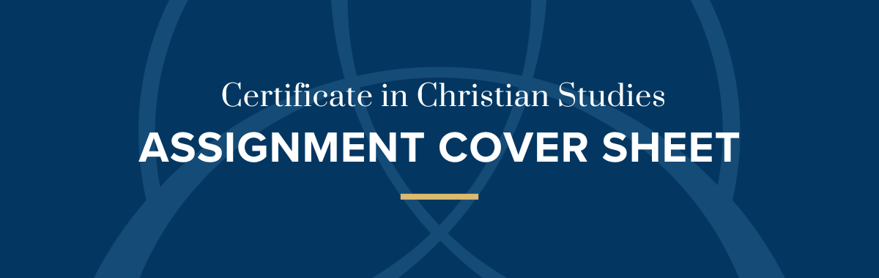
Student Name:
Unit:
Question:
Teacher:
Due Date: |  | Word Count:

Result: Distinction Credit Pass+ Pass Revise

Comments:

Marker: Date:
This page is not required if submitting using the online form
Assessments can be submitted with this form via email to ccs@ttc.wa.edu.au
For alternative submission methods, please contact the CCS Coordinator

